AI Project Documentation Master Packet – Version 2
This document contains comprehensive project documentation for the Recreational Area AI Attendance Prediction and Staffing Optimization Initiative. Each section is written in professional business format to demonstrate the documentation typically required throughout the lifecycle of an AI implementation project.

Requirements Document
- Business Objective: The organization seeks to improve operational efficiency by using AI to forecast visitor attendance and proactively staff the recreational area accordingly.
- Functional Requirements: The system must accept attendance, weather, holiday, and local event inputs and generate daily attendance forecasts.
- Non-Functional Requirements: The model must provide predictions within 10 seconds and maintain 90%+ forecast accuracy.

Feasibility Study
- Technical Feasibility: Existing attendance and weather datasets support model training.
- Operational Feasibility: Staff are capable of using dashboard outputs after brief training.
- Financial Feasibility: Estimated implementation costs are outweighed by projected labor savings within 18 months.

Project Scope
- In Scope: Attendance forecasting, staffing recommendations, dashboard creation, reporting outputs.
- Out of Scope: Payroll integration, HR automation, scheduling approvals.

Model Documentation
- The forecasting model uses supervised learning with regression analysis to estimate attendance.
- Inputs include weather forecasts, seasonal trends, prior attendance, and event calendars.
- Outputs include projected visitor totals and suggested staffing levels.

Explainability Report
- The model flagged August 14–16 as a high-volume period.
- Primary contributing factor: Annual regional summer festival occurring nearby.
- Secondary contributing factors: Warm weather forecast and weekend timing.

Test Documentation
- Test Methodology: Historical data from the past three years was used for validation.
- Accuracy Result: Average forecast deviation remained under 8%.
- Stress Testing: Model tested against holiday spikes and severe weather anomalies.

Privacy Document
- Only aggregate attendance and operational data are collected.
- No facial recognition, biometric, or personal identity information is stored.
- All data is encrypted at rest and in transit.

User Guide
- Step 1: Access the AI dashboard via company intranet.
- Step 2: Select desired forecast range.
- Step 3: Review staffing recommendations and export if needed.

Maintenance Log
- January: Added weighting for rainy-day attendance reduction.
- February: Improved festival/event detection logic.
- March: Updated staffing recommendation ratios after management review.

Supporting Artifacts
The following artifacts provide supplemental support for project planning, explainability, and operational review.

Historical Attendance Artifact
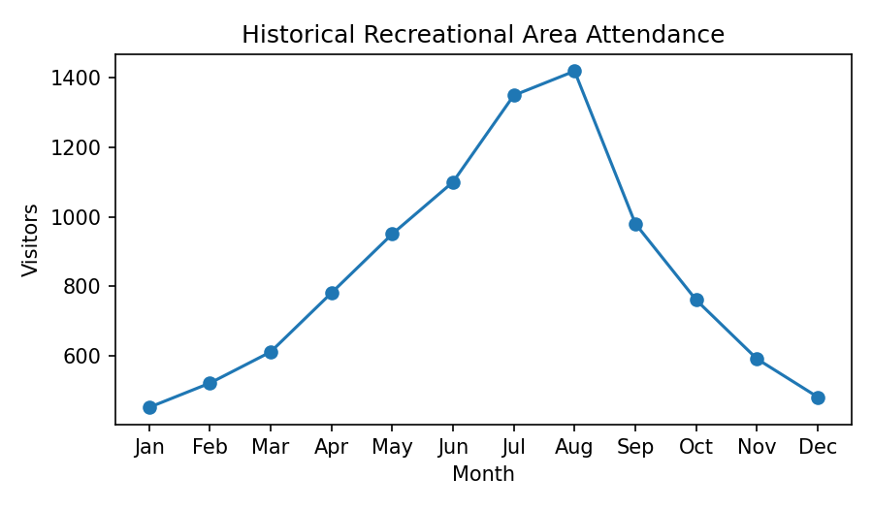

Prediction Reasoning Artifact
Forecast Date | Predicted Attendance | Confidence | Primary Reason
July 4 | 1,600 | 95% | Holiday Celebration
August 15 | 1,450 | 92% | Summer Festival
November 10 | 500 | 80% | Off-season / Cold Weather

